 | 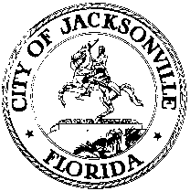
 | OFFICE OF THE CITY COUNCIL
Samuel C. Newby  COUNCIL PRESIDENT  Group 5, At-Large |  | SUITE 425, CITY HALL  117 WEST DUVAL STREET
OFFICE (904) 255-5219 |  | JACKSONVILLE, FLORIDA 32202
FAX (904) 255-5230 |  | E-MAIL: SNEWBY@COJ.NET

September 14, 2021
10:00 A.M.

TO: Honorable Council Members
FROM: The Honorable Sam Newby, Council President
SUBJECT: 20210914 Memorandum The Standing Committee Appointments for Rules,
TEU and TDC
_____________________________________________________________________
In accordance with Council Rule 2.103 (a), as President of the Jacksonville City Council, I hereby appoint Council President, Sam Newby to the Rules Committee, Council Vice-President Terrance Freeman to the Transportation, Energy and Utilities Committee (TEU) and Former Council President Aaron Bowman, to the Duval County Tourist Development Council (TDC), effective today, September 14, 2021.
I appreciate each of the Council Members who have made the commitment to serve on these important committees.
cc: Council Members/Staff
Cheryl L. Brown, Director/Council Secretary
Jessica Matthews, Chief, Legislative Services Division
Kim Taylor, Council Auditor
Jeff Clements, Chief, Research Division
CITYC@COJ.NET
Media Box
File Copy

